Elery Hamilton-Smith, AM  Chair  Task Force on Caves and Karst  Prof. Elery Hamilton-Smith, AM  P.O. Box 36, Carlton South, Victoria 3053, AUSTRALIA.  Telephone: (+613) 9489.7785  e-mail: <elery@alphalink.com.au> | IUCN  The World Conservation Union

16 August 2004

Prof Cao Jianhua
Institute of Karst Geology
50 Qixing Rd 541004
Guilin
Guangxi,
China.

Dear Professor Cao Jianhua

I am delighted to invite you and your wife, Wei Yongqun, to attend the Limestone Coast 2004 Conference.

This will be held at the Naracoorte Caves World Heritage Area in South Australia on the 10th-17th October, together with a number of pre-conference and post-conference events.

We do look forward to meeting you, and trust you will have an indeed interesting visit. We also trust your arrangements proceed smoothly, and do let us know if we can assist you in any way.

Sincerely

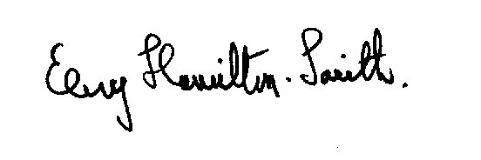
Elery Hamilton-Smith

